Physics 100 (Stapleton) Name: ______________________________
Midterm Review

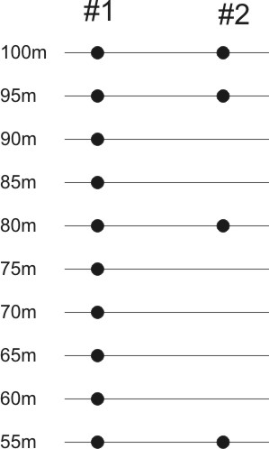
Note: If you can correctly complete all of the portions of this review – and if you understand the underlying concepts – then you can be confident that you will perform well on the final.

1. The dots to the right represent the positions of two 50kg base jumpers, after each second of their fall. The distances on the left represent their heights. One of the jumpers is in free fall. The other has a parachute open and is falling with constant velocity. The jumpers jumped from a height of 100m.

- What is “free fall?”

- Which jumper is in “free fall?”

- What are the average velocities of the jumpers between the 95m and 80m positions?

#1’s velocity = _________

#2’s velocity = __________

2. Suppose an object is dropped from a tall building. When the object is released, it begins to free-fall. On the velocity graph, below, show the object’s velocity during the first 4 seconds of its fall. Then fill out the acceleration graph. Be sure that your signs are correct!

3. A ball is thrown upward into the air. It goes up, and it comes down. Fill in the missing data in the diagram below. Note that you are given the starting time and the ending time. You must figure out the rest. Make sure to use correct signs!
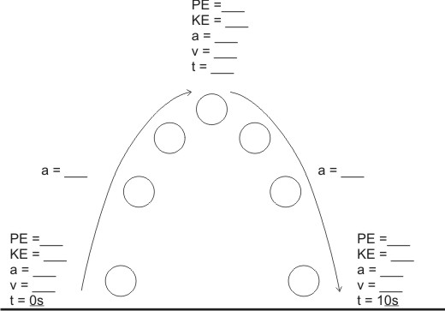
Height = _____

.4. What is the difference between velocity and speed?

5. If Matilda is driving her car at a speed of 40m/s, what is her approximate speed in miles per hour?

6. If I say that someone has a velocity of 6m/s, what does that mean? [Do not just spell out 4m/s; demonstrate that you know what this really means by saying it in a different way.]

7. Agatha has an acceleration of 6m/s². What does that mean?

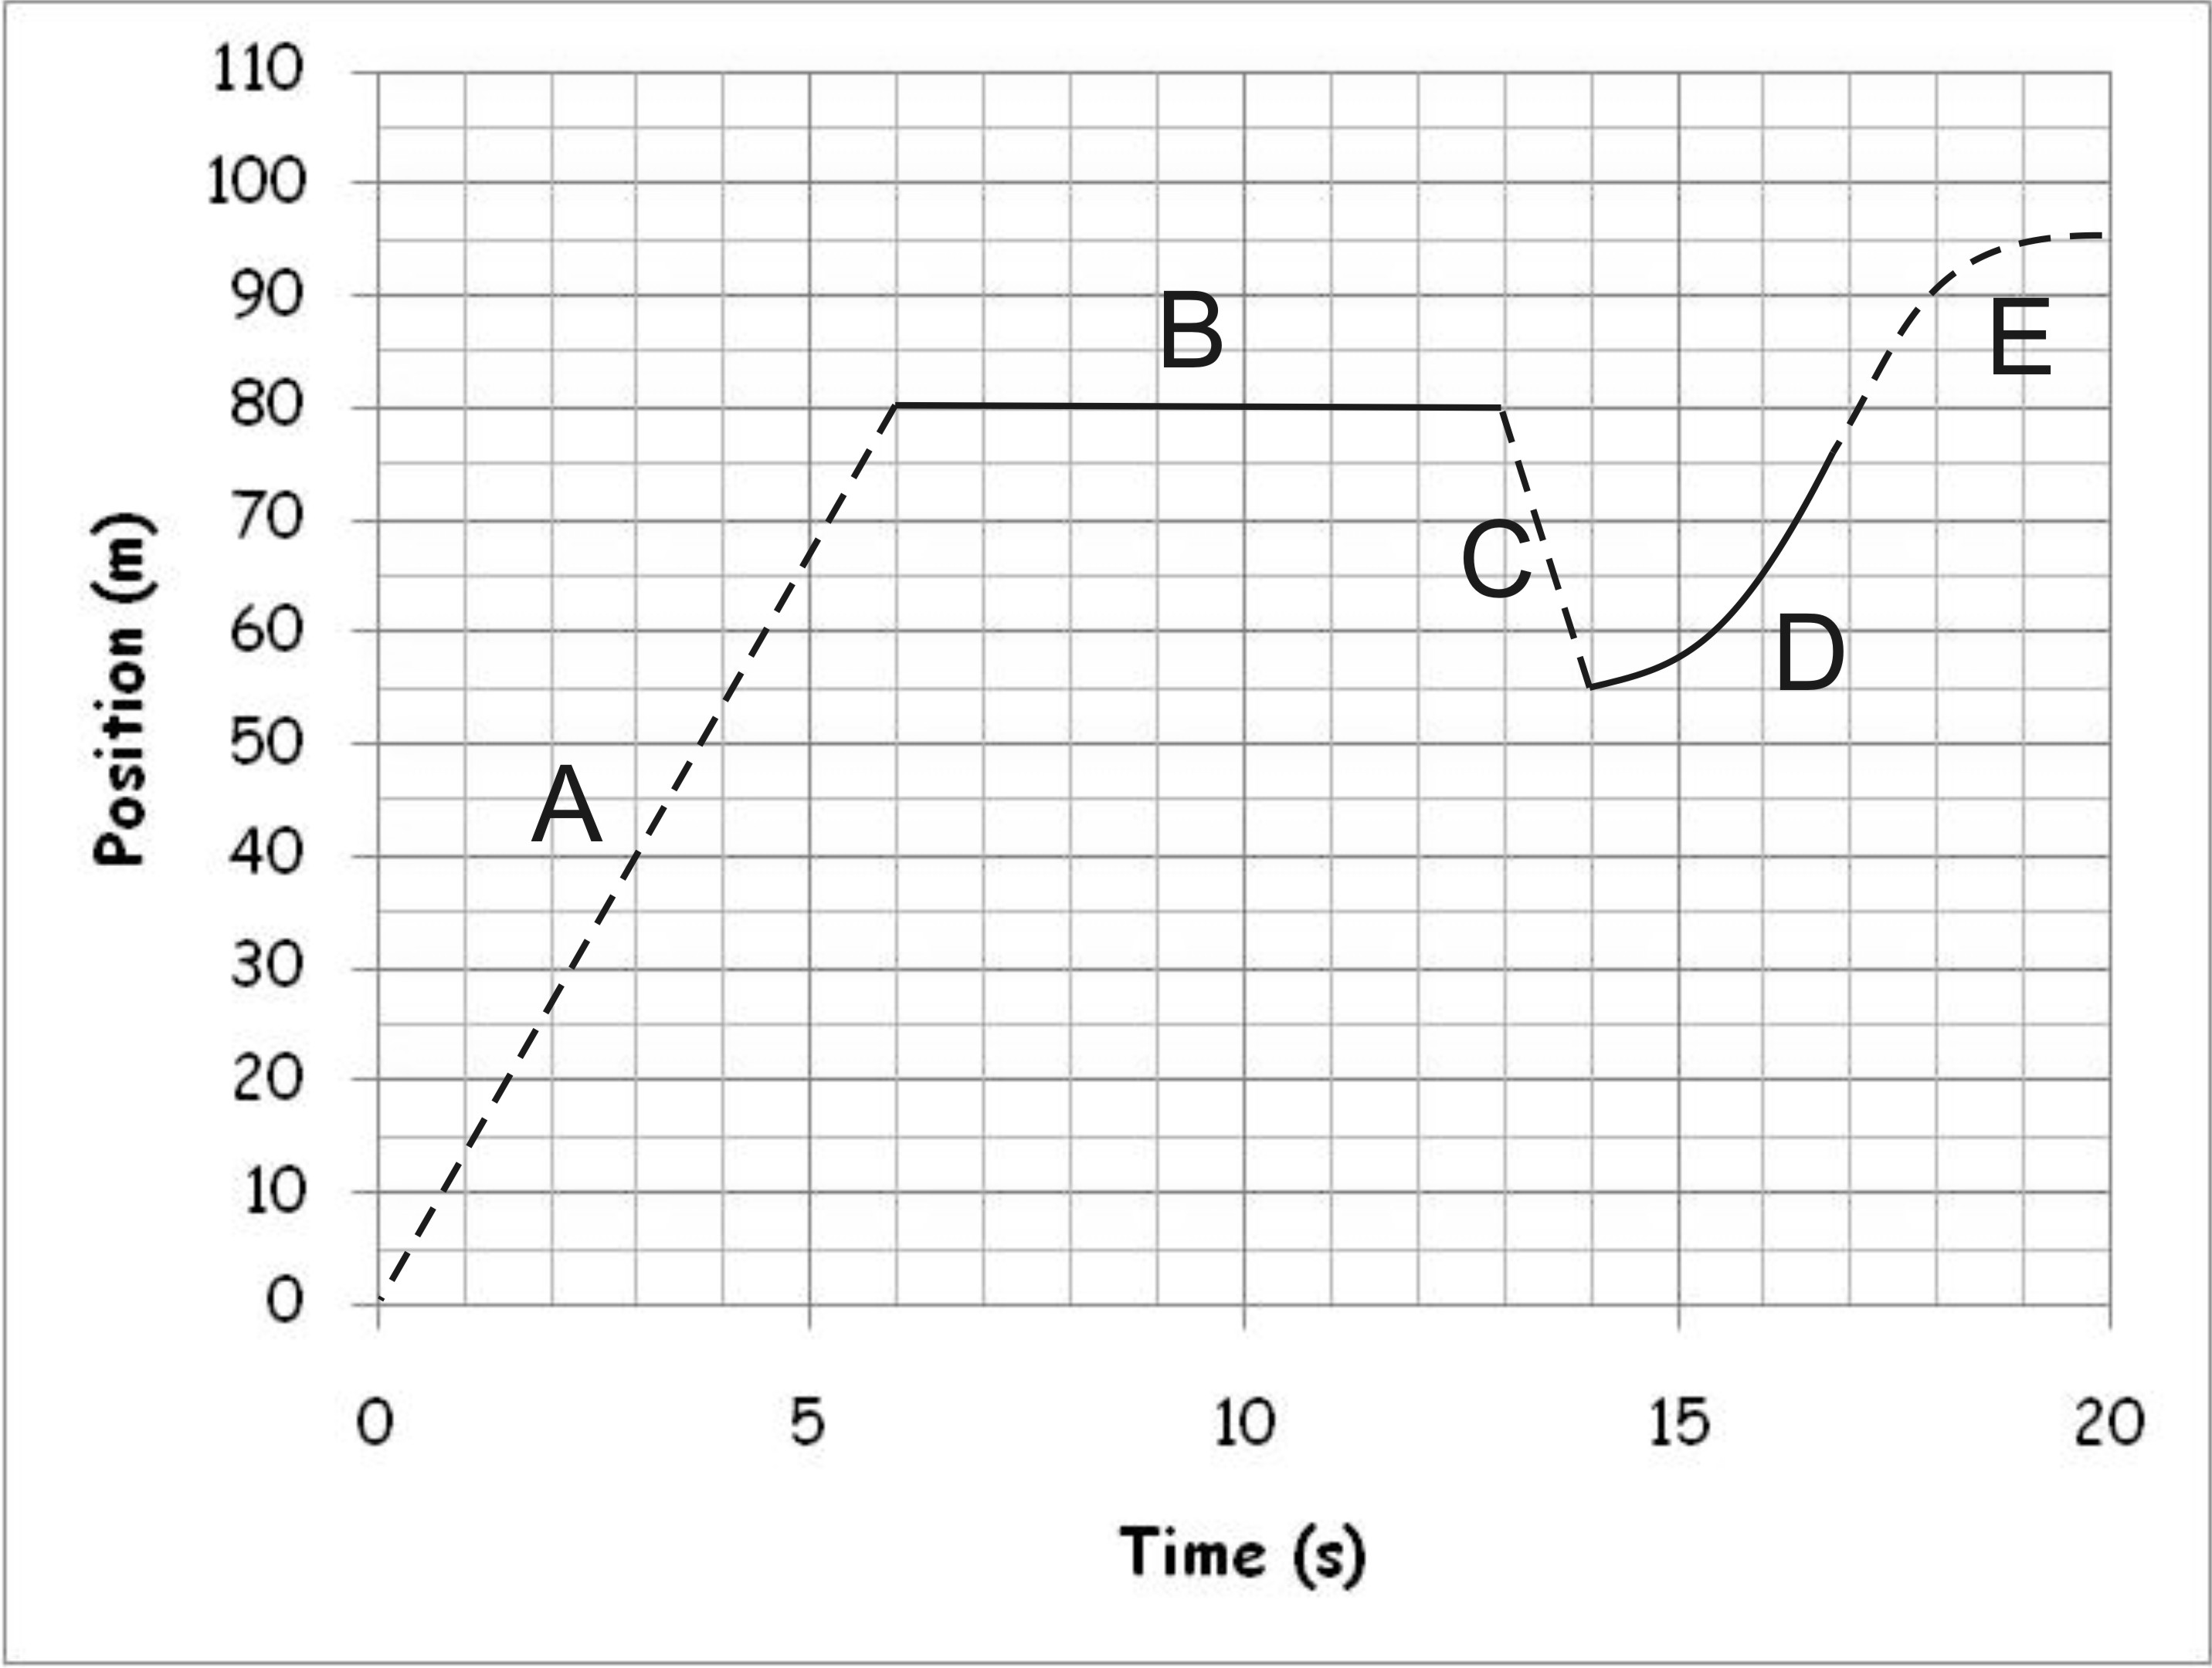
8-12. The graph on the right shows the movement of an object relative to a motion sensor. The purpose of the alternating dotted and dashed lines is to allow you to distinguish between the lettered segments.

8. During which segment is the object motionless?
9. During which segment is the object decelerating?
10. During which segment does the object have the fastest constant speed (not velocity)?
11. During which segment is the object moving backward?
12. What was the average velocity during segment B?

13. Match each position vs. time graph to a velocity vs. time graph and an acceleration vs. time graph.

Velocity graph: ___ Velocity graph: ___ Velocity graph: ___ Velocity graph: ___

Accel. graph: ___ Accel. graph: ___ Accel. graph: ___ Accel. graph: ___

D
C
B
A

C
B
A

14. An object travels 8 meters in the 1st second of travel 8 meters again during the 2nd second of travel and 8 meters again during the third second of travel. Its acceleration during this time period is:
a) 0 m/s² b) 8 m/s² c) 16 m/s² d) 32 m/s²

15. When an object is in free-fall (i.e. neglecting any air resistance), which of the following apply(ies)?
a) velocity increases b) acceleration increases
c) speed increases d) All of these

16. The graph on the right shows the distance traveled by a bicyclist.
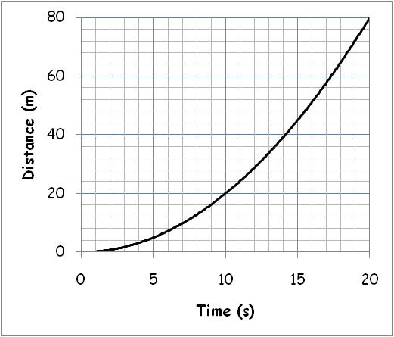
#1
- What was the average velocity of the bicyclist during the last 10 seconds (from 10s to 20s)?

- What was the bicyclist’s acceleration throughout the time period?

17. A rock falls from the edge of a cliff and hits the bottom 10 seconds later. How high is the cliff?

18. How long does it take Barbara to run from her Physics class to her French class? She runs with a speed of 3 m/s and the classes are 1000 m apart.

19. Suppose a 75kg world class sprinter accelerates at a rate of 3 m/s². Starting from a standstill, he eventually reaches a speed of 12 m/s on a flat, horizontal surface. During this acceleration, the sprinter undergoes a change in potential and kinetic energy. This is because the runner is doing work.

a. How long does it take the sprinter to accelerate to 12 m/s?

b. What average force was applied by the sprinter during the acceleration period?

e. How far does the sprinter travel in the course of accelerating to 12m/s?

f. How much work does the sprinter do during this acceleration period?

g. How much power does the sprinter generate during this acceleration period?

20. A bumbling clown drops a 0.2kg rubber chicken from a height of 960m. Assume that there is no air resistance.

a. What is the chicken’s acceleration?

b. How long does the chicken take to fall to the ground?

c. What is the weight of the rubber chicken?

d. How much work is done (by gravity) on the chicken while it is falling?

f. What is the velocity of the chicken just before it hits the ground (include correct sign)?

g. How much power is generated by the falling rubber chicken?

21. Is energy a vector quantity or a scalar quantity? Explain.

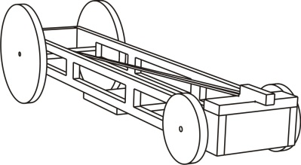
22-32.

The questions in this section refer to the 0.2kg rubber band car shown on the right. A student wound the car by pushing it backward for a distance of 3m. The average force applied by the student during this process was 5N. The graph below shows how the car’s velocity changed after it was released. After traveling for 9 seconds, the car hit a wall and came to an abrupt stop. The car has drive wheels with a radius of 0.08m and a drive axle with a radius of 0.005m.

Mass | Distance pushed during winding process | Average force applied during winding process | Drive wheel radius | Drive axle radius
0.2kg | 3m | 5N | 0.08m | 0.005m

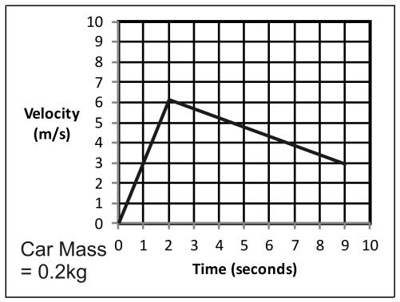
22. What was the car’s acceleration during the acceleration phase?

23. What was the car’s acceleration during the deceleration phase?

24 Complete the diagrams below by entering the correct component forces and net forces for the acceleration and deceleration phases. ***You can assume that the motor force is zero during the deceleration phase. ***You can also assume that the force of friction is the same during both phases.
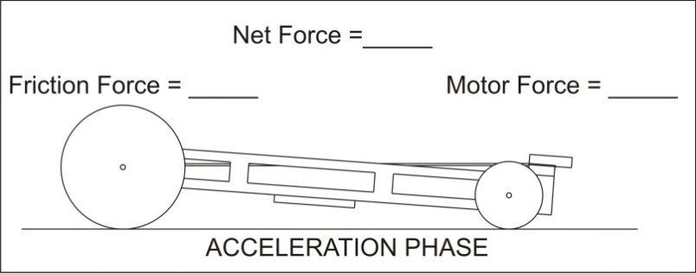

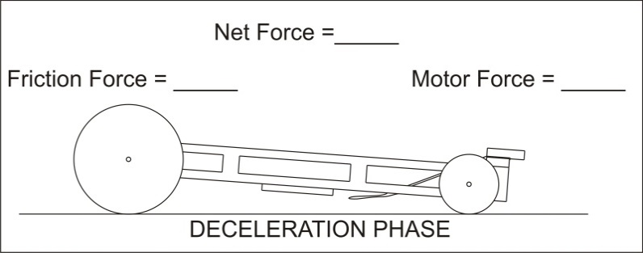

25. What was the car’s maximum velocity?

26. How much work was done in the winding of the rubber bands?

27. What was the car’s energy input? ________ Energy output? _______ Efficiency? _______

28. How net power did the car generate during the acceleration period?

30. What was the car’s drive wheel/axle torque during the its acceleration period?

31. What was the force of tension in the string during the acceleration period?

32. If the string tension represents the input force, and the wheel force represents the output…
a. What is the car’s mechanical advantage?
b. What is the usual purpose of machines with a mechanical advantage greater than one?
c. What is the usual purpose of machines with a mechanical advantage less than one?

33. Newton’s 1st Law (the law of inertia) states that objects _______________________________________

_____________________________________________________________________________________

unless _______________________________________________________________________________

34. True or false: there is no net force acting on the Earth because the Earth’s orbit around the sun is steady and unchanging.

35. True or false: As long as your car’s speedometer reads a constant 60mph, you can be confident that there is no net force acting on your car.

Suppose a ball is thrown straight up into the sky, in the absence of air (ignore air resistance).

36. During the ball’s flight, when is the net force on the ball zero?
a. just after being thrown b. at the highest point
c. just before landing d. both a and c
e. never

37. During the ball’s flight, when is the ball’s velocity zero?
a. just after being thrown b. at the highest point
c. just before landing d. both a and c
e. never

38. During the ball’s flight, when is the ball’s acceleration zero?
a. just after being thrown b. at the highest point
c. just before landing d. both a and c
e. never

39. During the ball’s flight, when is the ball’s kinetic energy zero?
a. just after being thrown b. at the highest point
c. just before landing d. both a and c
e. never

40. During the ball’s flight, when is the ball’s potential energy zero?
a. just after being thrown b. at the highest point
c. just before landing d. both a and c
e. never

41. A 2kg ball is sitting motionless on the ground.

- What is the force of gravity that is acting on the ball?
- What net force is acting on this ball?
- Besides gravity, what else is exerting a force on the ball?

Newton’s 3rd Laws states that, for every action, there is an equal and oppositereaction…

42. What are the action and reaction forces that are involved when a skydiver falls to the Earth?

43. Explain why it is hard to accelerate when you’re standing on very slippery ice.

44. Suppose you’re floating around in space, and there is zero gravity. You have two seemingly identical boxes, but one has more mass than the other.

- Describe a test you could do to find out which box has the most mass.

- Explain how you would analyze the results of your test.

45. a. If you were to travel to the moon, what about you would change, your mass or your weight?

b. Explain why one would change and the other would not.

46. You are standing still on a frictionless frozen lake in frictionless air. You have nothing except for a 5kg bowling ball. Your mass is 80kg. To get to the edge of the lake, you give the ball a 100N push directly away from the shore. After you push the ball for a distance of 0.7m, your arms are fully extended, and the ball flies out of your hand. What is your speed just after you release the ball?

47. When the mass of an object is kept constant, how does the acceleration of the object relate to the net force applied to the object?
A) Acceleration doesn't depend on net force at all.
B) Acceleration is directly proportional to net force.
C) Acceleration is inversely proportional to net force.

48. When the force applied to an object is kept constant, how does the acceleration the object relate to a change in the object’s mass?
A) Acceleration doesn't depend on mass at all.
B) Acceleration is directly proportional to mass.
C) Acceleration is inversely proportional to mass.

49. Circle the answer that correctly completes the following sentence. When you jump out of a plane, before you reach terminal velocity…
a. your weight equals air resistance. b. your weight is greater than air resistance.
c. air resistance is greater than your weight. c. air resistance is equal to your mass.

50. When you are falling at terminal velocity, what is happening to each of the following? Do they increase, decrease, or remain constant?
- KE
- PE
- Total energy
51. When you are free-falling, what is happening to …
- KE
- PE
- Total energy

Matching: (Each answer is used exactly once.)
Answers: a. inertia b. acceleration c. scalar d. Force e. terminal velocity
f. friction g. vector h. weight i. torque j. power
k. efficiency l. machine m. work

52. _____Resistance to change in motion
53. _____ Tells us how much energy is wasted during some process
54. _____ A twisting force
55. _____Having a magnitude but not a direction
56. _____A measure of how fast velocity is changing
57. _____ How much work is done in each second.
58. _____A push or a pull
59. _____ A force applied for a distance
60. _____Caused by microscopic bumps in the surfaces of objects
61. _____When weight equals air resistance
62. _____The force of gravity
63. _____ Makes work easier by changing force, distance, and/or direction
64. _____Having both a magnitude and a direction

Matching Units: (Answers are used more than once!)
Choices: Newton kg s m/s² m/s N•m j m

65. torque
66. air resistance
67. force
68. speed
69. friction
70. mass
71. time
72. work
73. weight
74. energy
75. acceleration
76. velocity
77. distance

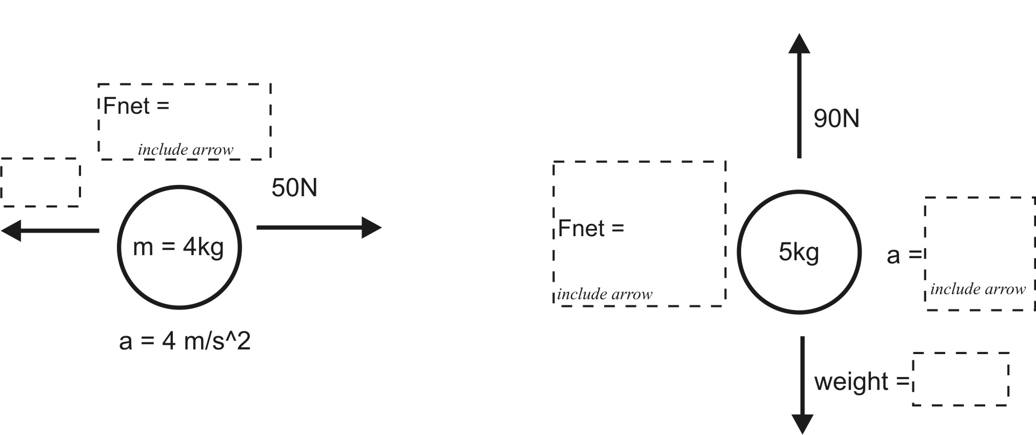
78. Fill in the dotted boxes on the right. Be sure to label with correct units!

79. A net force of 0N (zero net force) is acting on a person. With regard to the person’s motion, what are the two fundamentally different possibilities for what that person might be doing?

Possibility 1.

Possibility 2.

80. What is the mass of an object that has a weight of 10 N on the Earth?

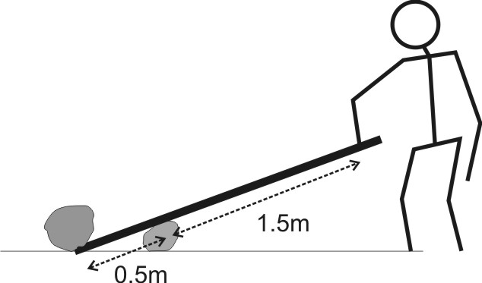
81. Wanda is lifting a rock by using a lever(see diagram). Wanda pushes down on the lever with 100N of force.
a. How much force is applied to the rock?
b. What is the mechanical advantage of wanda’s machine?

82. Suppose you want to loosen a nut that is firmly screwed onto a bolt. You have a 0.2m long wrench, and you can generate a maximum force of 200N, but that’s not good enough. In order to loosen the nut using your particular wrench, you would need to apply a 600N force at the end of the wrench.

- How much torque is required to loosen the nut?

- You can remove the nut if you extend your wrench. How long (minimum) does your wrench need to be so that your 200N of force is sufficient for loosening the nut?

83. The first table, below, is a timeline detailing a parachuter’s descent from an airplane. The second table is an incomplete analysis of mass, forces, and acceleration relating to the parachuter’s fall. Use the timeline and your knowledge of physics to complete the second table. Pay close attention to the times in the second table. Most of them do not coincide with the times in the first table, but you can still use the first table to complete the analysis for those times. Before you go too far, it would be prudent to first identify the times in the second table at which the parachuter has reached terminal velocity.

Time | Event
0s | Parachuter steps out of plane
14s | Parachuter reaches a first terminal velocity of 50m/s
24s | Parachuter pulls chute cord. Chute deploys.
29s | Parachuter reaches a second terminal velocity of 4m/s
375 | Parachuter lands
**Please include arrows to show direction.**
Time | Parachuter Mass | Parachuter Weight (plus direction) | Air Resistance (plus direction) | F_{net}  (plus direction) | Acceleration  (plus direction) | Speed
0s | 50kg
5s |  |  | 300N Upward |  |  | 20 m/s
18s
25s |  |  | 1250N Upward |  |  | 40m/s
220s

84. You take a video of your friend riding down the street on a skateboard. You are using an ordinary camera or smart phone, so the frame rate is 30fps. You open up the video and click frame-by-frame as your friend rolls past a car. The length of the car is 5m, and your friend rolls past the car in 18 frames.
a. How long did it take for your friend to roll past the car?
b. How fast was your friend going?

Formulas:
d
v
t
d = vt v = t =
d = t = a=2d/t²
v
a
t
v = at a = ∆v/∆t t=v/a
g = 10 m/s²

F_{net} = m a m = F_{net}/a a = F_{net}/m Weight = m g g = 10 m/s²

T = fr
W = fd
KE = ½ mv²
$$v= \sqrt{\frac{2KE}{m}}$$
PE = mgh
Efficiency = (energy output / energy input) * 100%
MA = $\frac{input distance}{output distance}$
Video time elapsed = # of frames/frame rate
1000g = 1kg
W ≈ ΔEnergy
1 Watt ≈ 0.00134hp

